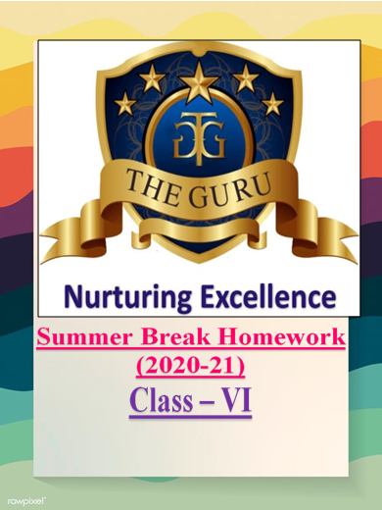
Social Science:
• “Reading gives us some place to go when we have to stay where we are”.
So dear children, make reading a habit. Read Chapter - 2 of History, Civics and Geography. Highlight the important points and make a note in your fair notebooks.
• Display your creativity :
✓ Prepare a collage highlighting diversity in India. (Hints : You can use cuttings from newspaper, magazines, pictures from your surroundings, family, etc.)
OR
✓ Prepare a model showing the solar system or different phases of Moon (Use material available at home).
Computer Science:
• Read chapters (1 and 2) that we have already done and learn exercises and question answers.
• Prepare a chart displaying"Microcomputers" and mention their name and show your creativity. (Hint: You can use drawing sheet or coloured sheet from your old scrap book or any chart paper available at home.)
NOTE: If you have any difficulty to find out the Microcomputers, just open your book and refer page no. 10 to 12
English
1. Make a vocabulary notebook and note down difficult words.(Unit 1,2and3)
2. Read 'Tom Paints The Fence' and 'Dear Mr Examiner' and brief them in 120 words each.
3. Write a paragraph (60-80 words)
Sympathy with animals
4. Make a chart of Noun with its types.
5. Solve the exercises of 'The sentence',' Phrases and Clauses' and 'The Simple Sentence' of your textbook.
Science
- Collect the sources of different nutrients ( carbohydrates, fats, proteins, minerals and vitamins in mini- sachets and paste them in your scrap book .
- Make a chart of vitamins and minerals, sources and deficiency of them on chart paper.
- Make sketch of coronavirus covid-19 on A4 size paper and also write symptoms and precaution of it.
- Read chapter 1 and 2 from your book and learn exercises and question answers.

Maths
Activity
- Objective- To understand and read 5-digit number ( page number- 23)

Activity
- Objective- To verify that addition of whole numbers is commutative ( page number- 45)
(Dear students I am also giving you the pictures of the following activities. You just go through these activities and perform it in chart paper)
- Dear students you have to do the revision exercise of chapter-1(knowing our numbers) page number-220
- Revise and practice of all exercises of chapter-1 (knowing our number) page number 5-24.
Hindi

I ) लिखितवमौखिकभाषाकेउदाहरणचित्रद्वारादीजिये।
II) पांचफलों,पांचशहरों,पांचसब्जियों,पांचमित्रों,पांचवस्तुओंतथापांचमहापुरुषोंकेनामरोमनवदेवनागरीलिपिमेंलिखिए।
III) लॉकडाउनकीअवधिपरघरवपरिवारकेसाथव्यतीतकियेगएसमयकाअनुभवअनुच्छेदमेंलिखकरबताइये। ( शब्दसीमा 100 - 120 शब्द )

